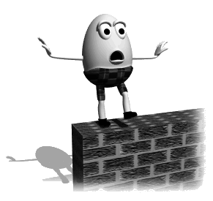
Exclusive Report by
How’s Jack? We speak to Jill. Full report on the hill accident on page 2!
Published by www.communication4all.co.uk
Date:

