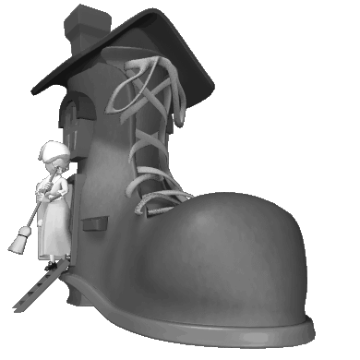
Exclusive Report by
Three Blind Mice robbed my farm!! We talk to the farmer on page 3
Published by www.communication4all.co.uk

Date:

