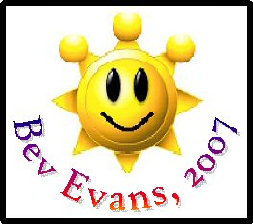
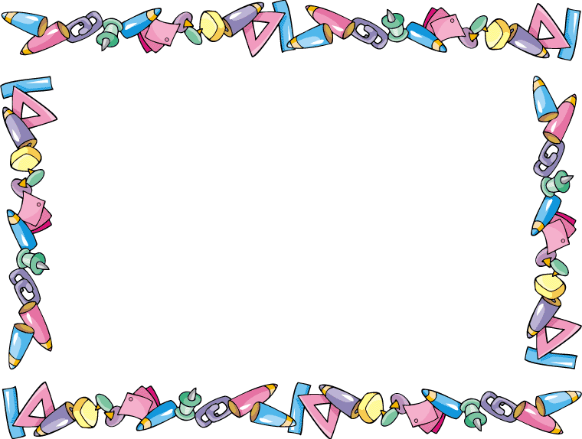
These labels are ©Bev Evans 2007, www.communication4all.co.uk . They can be typed into directly using Sassoon Infant font, 36pt

