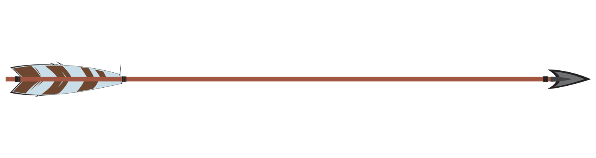


My Targets

Name:
Class:

1.

2.

3.

Name:
Class:

1.

My Targets

My Targets

Name:
Class:

1.

1.

2.

3.

2.

3.

My Targets

Name:
Class:

1.

2.

3.

2.

3.

